
NOTE: This is an official document by Indexademics. Unless otherwise stated, this document may not be accredited to individuals or groups other than the club IDX, nor should this document be distributed, sold, or modified for personal use in any way.
IDX G9 Biology S STUDY GUIDE ISSUE 8
By Amy and Mya, Edited by Isabella

18.1 Finding Order in Diversity
Assigning Scientific Names
- Common names can be confusing because they vary among languages from place to place and different species may share a common name
- In 18th century scientists recognized this confusion, so they agreed to assign Latin or Greek names to each species
- Names could be long and difficult to standardize these names as different scientists focused on different traits --> didn’t clear up much confusion
Dichotomous Key
- Used to identify organisms
  - Series of paired statements or questions that describe alternative characteristics of an organism. Paired statement usually describes presence or absence of certain visible characteristic or structure
Binomial Nomenclature
- 1730s, Swedish botanist Carolus Linnaeus
- Two part scientific name written in italic
  - First word (genus) begins with capital letter and second word (species) lowercased
    - Ex. Ursus Maritimus
- Species name often description of important trait or organism’s habitat
- Writing Standards:
  - The first name is the genus name, the second name is the species name
  - The 1st letter of the genus name is capitalized
  - The species name is lowercased
  - Italics are used if the name is typed or printed
  - The name is underlined if handwritten
  - Genus name can be abbreviated to the initial letter after used in text
Classifying Organisms into Larger Groups
- Systematics: Science of naming and grouping organisms
  - Goal is to organize living things into groups (taxa, single: taxon) that have biological meaning
The Linnean Classification System
- Original classification system expanded to include seven hierarchical taxa
  - Kingdom, Phylum, Class, Order, Family, Genus, Species
  - King Philip Came Over For Green Soup
  - Kindly Put Clothes On Fat Grey Squirrels
- Classified according to visible similarities and differences
- But appearances can have mistakes (ex. Look different but DNA alike)and it’s hard to identify which characteristics are considered important
  - Modern systematics apply Darwin’s ideas of evolution to classification and look beyond to ask questions about evolutionary relationships
    - Assign species to larger group in ways that reflect how closely member of groups related

18.2 Modern Evolutionary Classification
Evolution: desent with modification
Phylogeny: the evolutionary history
Phylogenetic systematics: evolutionary classification, to group species into categories that reflect lines of evolutionary desent, rather than overall similarities and differences.
Clades
- consist of an ancestore organism and all its descendants (and nothing else)
- must be monophyletic group: includes all species thta are descended from a common ancestor
Cladistics: a method of classifying species of organisms into groups called claades
Paraphyletic group: consists of an ancestral species and some, but not all, of the descendants.

Clades and Traditional Taxonomic Groups (Taxa)
- Cladistic analusis shows that many traditional taxonomic groups do form valid clades.
  - Eg: Linnaean class Mammalia, tor exampe, corresponds to dade Mammalia.
- In other cases, however, traditional groups do not form valid clades.
  - Eg: Linnaean class Reptilia, which does not include birds, is therefore not a valid cade and not corresponds to clade Reptillia
- Mammals have the unique homologous characteristic ot producing milk. They form a clade
- Likewise, birds share the common characteristic of feathers. They also form a clade.
- Reptiles, as a group, consist of the crocochilians, lizards and snakes, tortoises and turtles and tuatara. However, they are not a clade. One of them is actually more closely relatet to birds.
- Instead, birds, dinosaurs, crocodiles, and all descendants living or extinct) of their most recent common ancestor form a clade.
Cladogram
- a tree diagram to link clades together
- links groups of organisms by showing how evolutionary lines, or lineages, branched at from common ancestors.
Building Cladogram
- The bottom, or "root", of the cladogram represents the common ancestor shared by all organisms on the cladogram
- Nodes
  - the branching points on a cladogram
  - denote a speciation event when a common ancestor splits into two, or more, species
- Branching patterns indicate degrees of relatedness amony organisms.
Derived Characters
- A trait that arose in the most recent common ancestor of a particular lineage clade and eas passed along to its descendants
Losing Trait
- The absence of a trait is not used as a derived character, because distantly related groups of organisms can lose the same character
- Example: both whales and snakes have lost the tetrapod character of four limbs, but they are not very closely related. Snakes are members of the clade Repilia, while whales are members of the clade Mammalia.

18.3 Building the Tree of Life
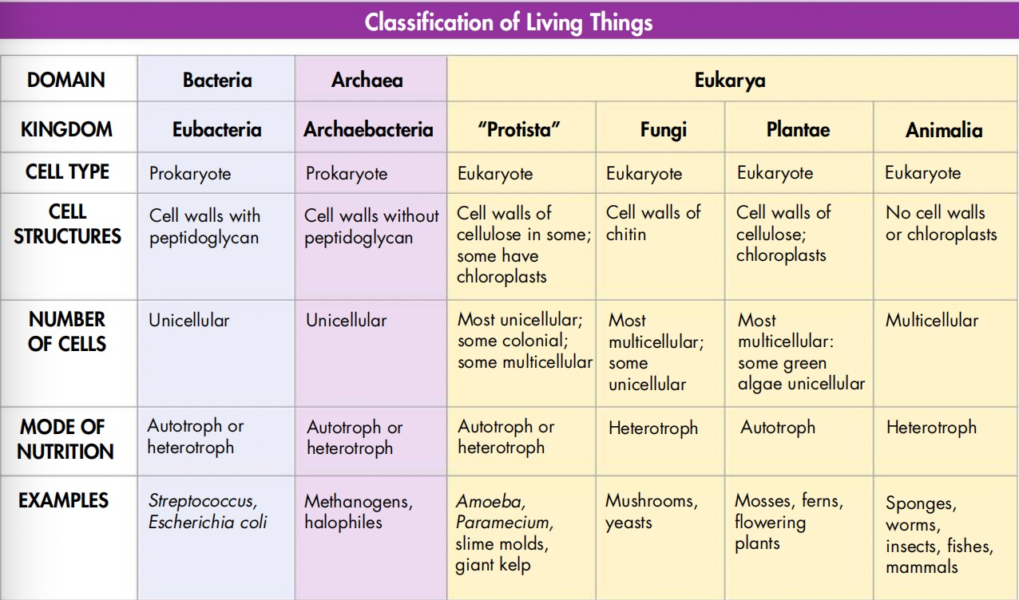
*King Proista is not a true clade! (paraphyletic)
Changing ideas about Domains
- All organism are classified into three domains
- Based on comparing base sequences of ribosomal RNA (rRNA) which evolves slowly
A domain is a larger, more inclusive category than a kingdom
Changing ideas about Kingdoms
- Previously prokaryotes were placed in one kingdom (monera) and eukaryotes in the remaining four
- Recent evidence from genetic studies of rRNA has shown that "prokaryotes/monerans" are far more diverse.

